LAB # 11
JUnit Testing and
Introduction to Test Suite

OBJECTIVE: Study the concept of Test Driven Development under the framework of JUnit
Testing and Grouping the multiple JUnit test cases and constructing a Test Suite program.

Lab Task:
• Add another test case for countA function (which is given in code).

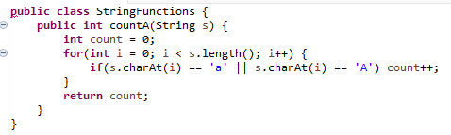

• Make a new project, make a class. Add 2 methods in it. One method will find the max integer present in the input integer array. The other method will find the min integer. Now create test cases for both these methods and test your code. Follow all the steps as mentioned above in the manual.
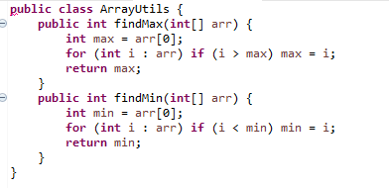
• Make a class having four functions for determining,
Whether the input integer is odd.
Whether the input integer is even.
Whether the input integer is prime.
For calculating the factorial of that input integer.
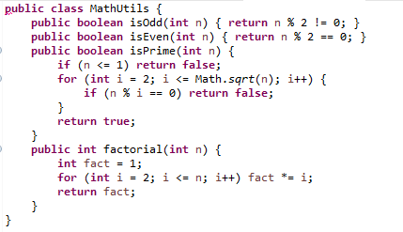
Write their test cases and execute them in a single test suite class. Follow all the steps
mentioned above in the manual.

StringFunctionsTest.java
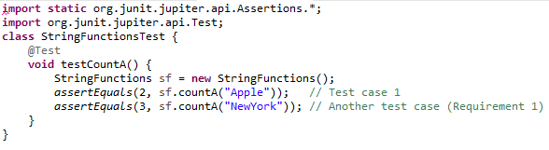
ArrayUtilsTest.java
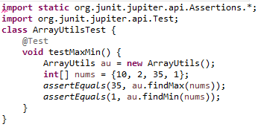
MathUtilsTest.java
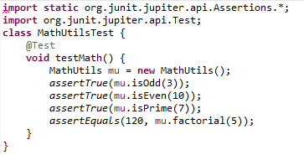

JUnit Test Suite(AllTests)
